**Week – 7**

**React**

**Objectives**

* **Explain various ways of conditional rendering**
* **Explain how to render multiple components**
* **Define list component**
* **Explain about keys in React applications**
* **Explain how to extract components with keys**
* **Explain React Map, map() function**

**In this hands-on lab, you will learn how to:**

* **Implement conditional rendering in React applications**

**Prerequisites**

**The following is required to complete this hands-on lab:**

* **Node.js**
* **NPM**
* **Visual Studio Code**

**Notes**

**Estimated time to complete this lab: 60 minutes.**

**Create a React App named “bloggerapp” in with 3 components.**

1. **Book Details**
2. **Blog Details**
3. **Course Details**

**Implement this with as many ways possible of Conditional Rendering.**

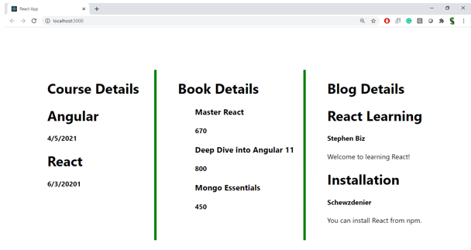

**Hint:**

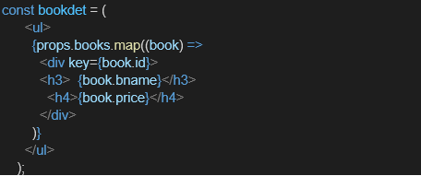

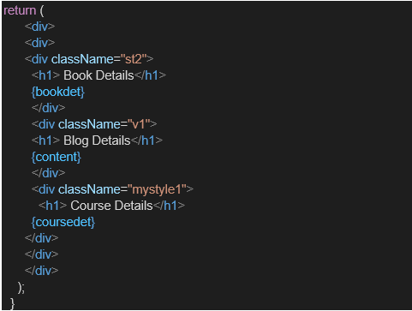

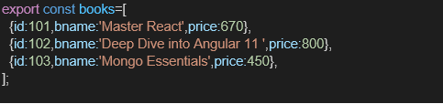

**IMPLEMENTATION :**

import React, { useState } from "react";

import ReactDOM from "react-dom/client";

function BookDetails() {

return (

<div>

<h2>Book Details</h2>

<p>Title: The Great Gatsby</p>

<p>Author: F. Scott Fitzgerald</p>

<p>Price: $15</p>

</div>

);

}

function BlogDetails() {

return (

<div>

<h2>Blog Details</h2>

<p>Title: Understanding React</p>

<p>Author: Jane Doe</p>

<p>Date: 2025-08-13</p>

</div>

);

}

function CourseDetails() {

return (

<div>

<h2>Course Details</h2>

<p>Course: React for Beginners</p>

<p>Instructor: John Smith</p>

<p>Duration: 6 weeks</p>

</div>

);

}

function App() {

const [view, setView] = useState("book");

const renderComponentIfElse = () => {

if (view === "book") {

return <BookDetails />;

} else if (view === "blog") {

return <BlogDetails />;

} else {

return <CourseDetails />;

}

};

const renderComponentTernary = view === "book" ? <BookDetails /> : view === "blog" ? <BlogDetails /> : <CourseDetails />;

const componentsList = [

{ id: 1, type: "book", component: <BookDetails /> },

{ id: 2, type: "blog", component: <BlogDetails /> },

{ id: 3, type: "course", component: <CourseDetails /> }

];

return (

<div>

<h1>Blogger App</h1>

<button onClick={() => setView("book")}>Show Book</button>

<button onClick={() => setView("blog")}>Show Blog</button>

<button onClick={() => setView("course")}>Show Course</button>

<h2>Conditional Rendering using If-Else</h2>

{renderComponentIfElse()}

<h2>Conditional Rendering using Ternary Operator</h2>

{renderComponentTernary}

<h2>Rendering Multiple Components with Map</h2>

{componentsList.map(item => (

<div key={item.id} style={{ display: view === item.type ? "block" : "none" }}>

{item.component}

</div>

))}

</div>

);

}

const root = ReactDOM.createRoot(document.getElementById("root"));

root.render(<App />);

**OUTPUT :**

